Name: John Snawerdt

Date: 1/17/2018

Course: CST 105

Milestone 1

Define a storyboard for an NFL Draft system that shows the workflow and proposed GUI for the draft system. I used the “Pencil” application to sketch this rough interpretation of a UI.

Start Screen

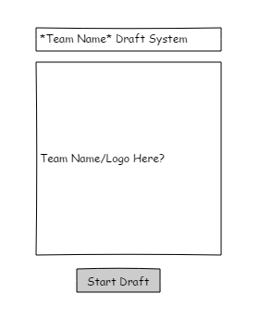

Simple page with team logo and a button to start the draft.

Main Page

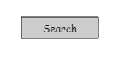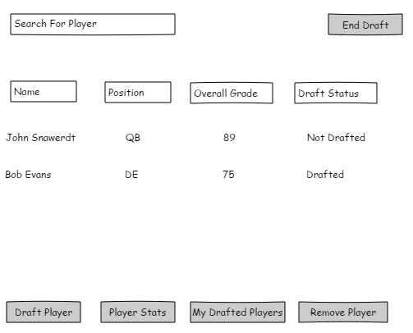

Here we can see the list of players in the draft, their position, overall grade (out of 100), and if they have been drafted or not. We can search for a particular player. “Draft Player” will draft the player to our roster. “Player stats” will show the stats for the player. “My Drafted Players” shows you the players you have drafted. “Remove Player” will remove the player from the list. The “End Draft” button will end the draft.

PLAYER STATS

The player stats menu will show the players information such as height and weight and then will also show relevant information for their position. For example, for QB we will add “accuracy” and “arm strength” as a stat. The table shows their stats and a rating for each as compared to other players. The final rating is shown below. There is a return button to return to the main draft screen.

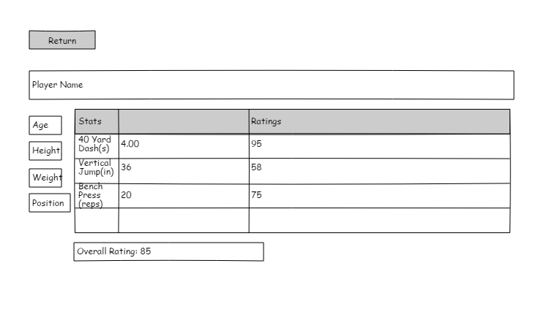

MY DRAFTED PLAYERS

My drafted players will show the players we have drafted along with their position and grade. We can also access the player stats card from here.

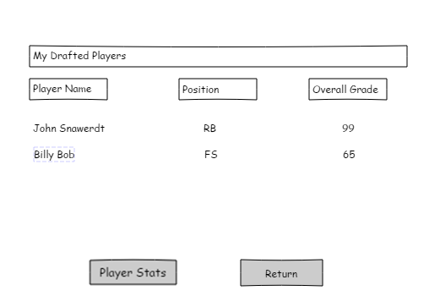

End Draft/Remove Player

The end draft button will end the draft and close the application. The remove player button will remove the player from the draft board. We will add a warning message so the user does not click them by mistake.

Warning message to make sure user does not accidently click and has to verify their selection.

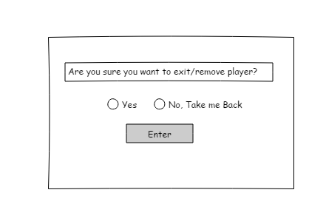

The search bar on the main page will be used to search for a player by name. It will only show that player or will be empty.